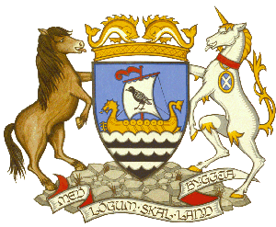
Shetland Islands Council
Town Hall Light Up Request
Please read notes at the bottom of the page before filling out this form
Charity / Organisation Name:
Name of Campaign:
Date/s of Campaign:
Date of light up request:
Colour/s you would like the Town Hall to be lit up:
Background information on the campaign:
Have you had the Town Hall lit up before for this campaign? Please provide details:
Please advise on what is being done locally in Shetland to raise the profile of your campaign and what local events are taking place:
Social Media information for the campaign. Please include any appropriate hashtags and any relevant organisations that we should tag in our posts:
If this is not available now – please send it to convener@shetland.gov.uk nearer the time

Contact Name:
E-Mail:
Phone Number:

Please return completed form to convener@shetland.gov.uk
If you require assistance you can e-mail the above address or phone 01595 744544.

NOTES

- The Town Hall can be lit up Monday – Friday. If it falls on a Saturday or Sunday, please select a weekday you would prefer to have it lit up.
- No light up requests will be taken between 1 April and 14 August due to the limited darkness in Shetland during the summer months.
- Due to the number of requests we receive to light up the Town Hall, we generally support local requests or ones that have local events and/or local fundraising taking place in Shetland to coincide with the campaign.
- Due to the number of requests we receive to light up the Town Hall, we ask that your request is for one day only.
- Light ups are generally aimed to raise awareness of charitable causes, health topics, or social messages. We will not support requests for light ups for campaigns that are political or commercial.
- Our communications team (where possible) will take a photo of the light up and share on our social media channels. Please note this cannot always happen due to the time it gets dark and the building not being staffed after 5pm.
- Your request will be sent to the Convener of Shetland Islands Council to consider and we will get back to you as soon as possible.

