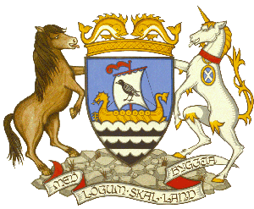
Shetland Islands Council
Town Hall Flag Flying Request
Please read notes at the bottom of the page before filling out this form
Charity / Organisation Name:
Name of Campaign:
Date/s of Campaign:
Date of flag flying request:
Flag you would like the Town Hall to fly:
Background information on the campaign:
Have you had this flag flying at the Town Hall before for this campaign? Please provide details:
Please advise on what is being done locally in Shetland to raise the profile of your campaign and what local events are taking place:
Social Media information for the campaign. Please include any appropriate hashtags and any relevant organisations that we should tag in our posts:
If this is not available now – please send it to convener@shetland.gov.uk nearer the time

Contact Name:
E-Mail:
Phone Number:

Please return completed form to convener@shetland.gov.uk
If you require assistance you can e-mail the above address or phone 01595 744544.

NOTES

- Flags can be flown from the top of the tower or from the flagpoles at the front.
- If you are providing us with a flag to fly, these are the flag dimensions and requirements:
Flag for Tower: 3 yard with a rope and toggle
Flag for front of Town Hall: 2 yard with a rope and toggle
- Flags can be flown Monday – Friday. If your campaign day falls on a Saturday or Sunday, please select a weekday you would prefer to have it flown.
- Flags will not be able to be flown if there is extreme weather (high winds, ice etc.).
- Due to the number of requests we receive, we generally support local requests or ones that have local events and/or local fundraising taking place in Shetland to coincide with the campaign.
- Flag flying days are generally aimed to raise awareness of charitable causes, health topics, or social messages. We will not support requests for campaigns that are political or commercial.
- Due to the number of requests we receive to fly flags at the Town Hall, we ask that your request is for one day only.
- Our communications team (where possible) will take a photo of the flag and share it on our social media channels.
- Your request will be sent to the Convener of Shetland Islands Council to consider and we will get back to you as soon as possible.

